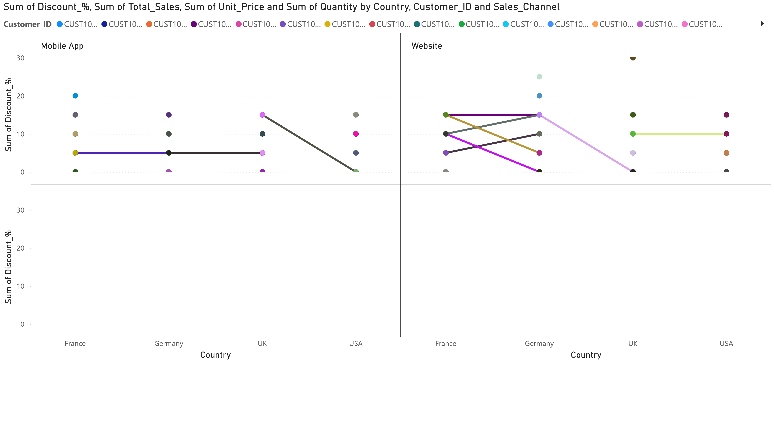
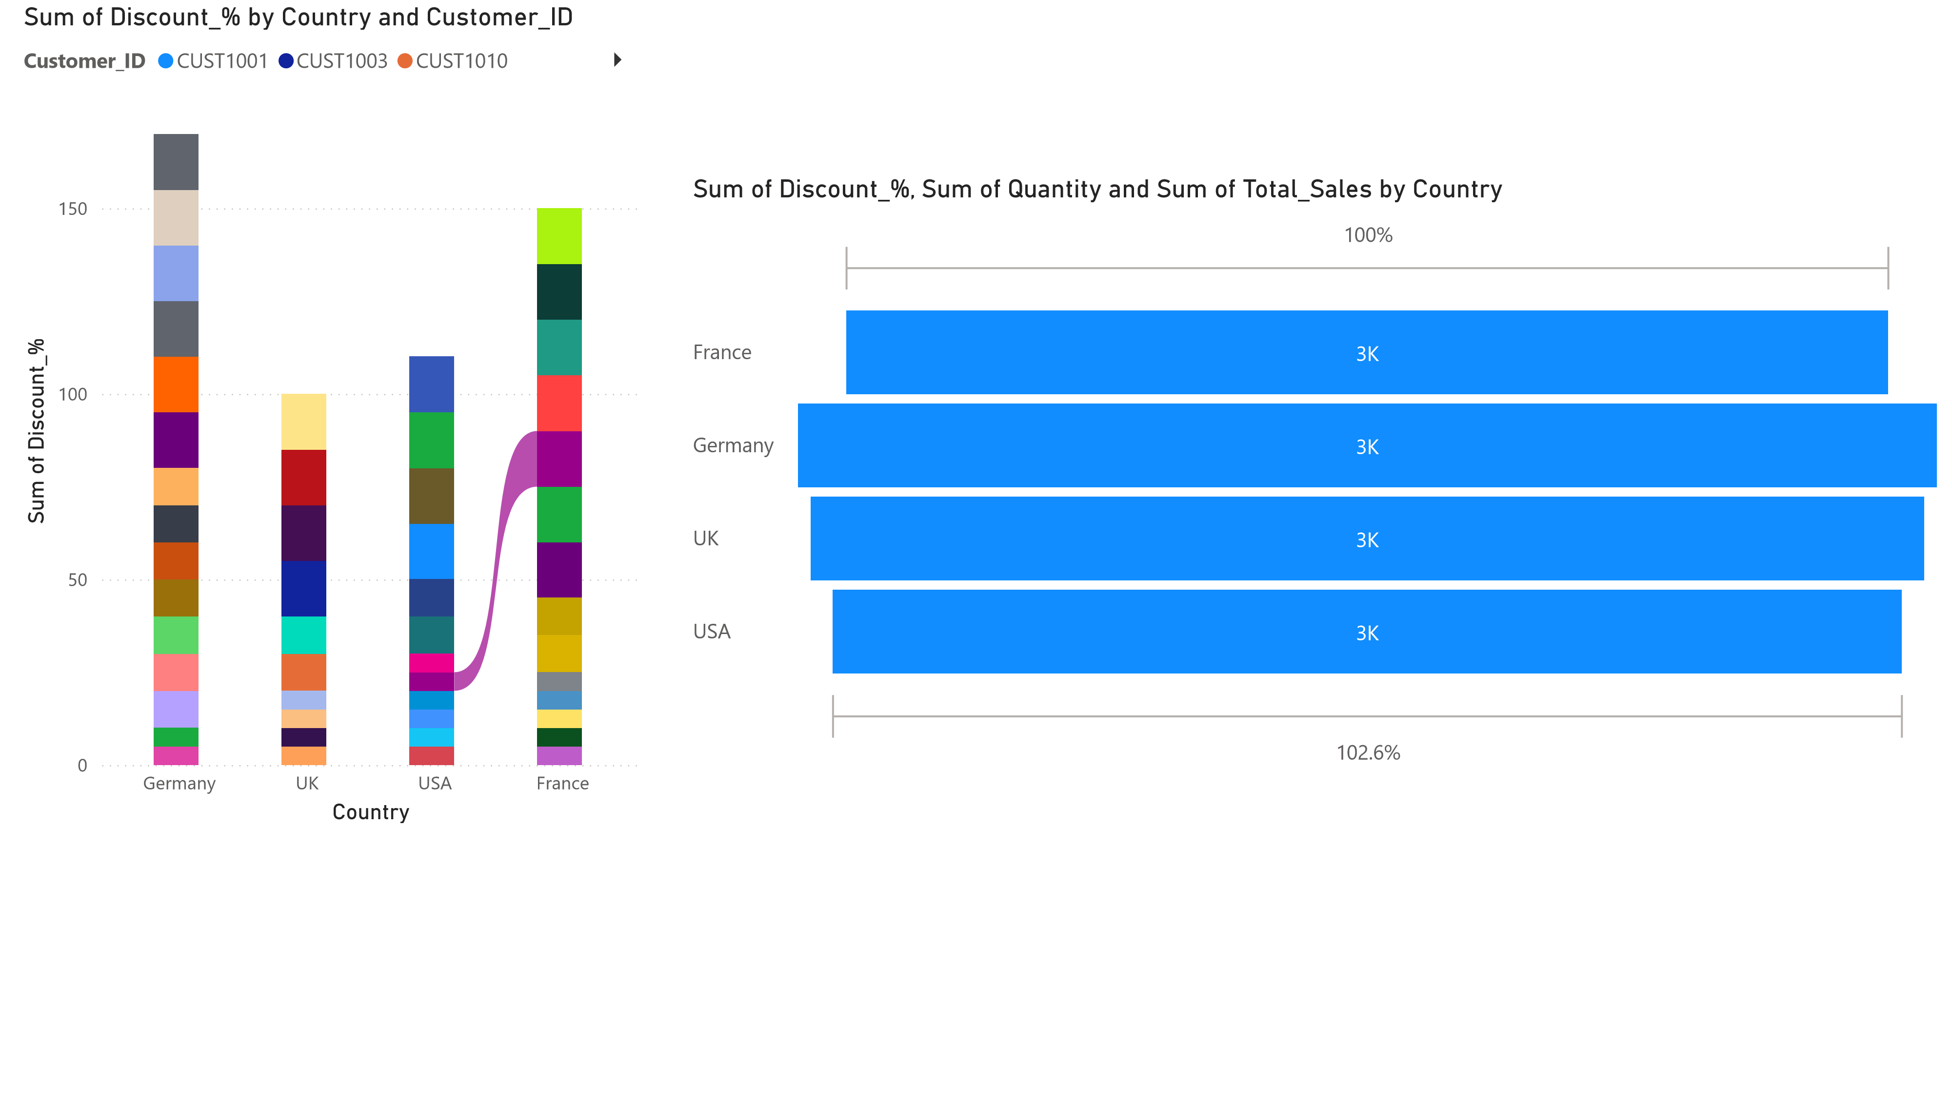
_{Power BI Desktop}
Sum of Discount_%, Sum of Quantity, Sum of Total_Sales and Sum of Unit_Price by Country
100
%
102.6
%
France
Germany
UK
USA
3
K
3
K
3
K
3
K
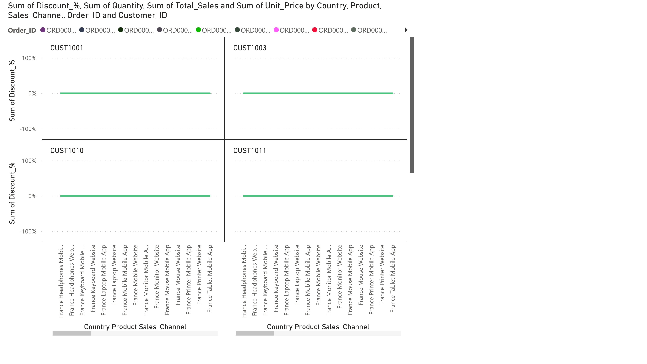
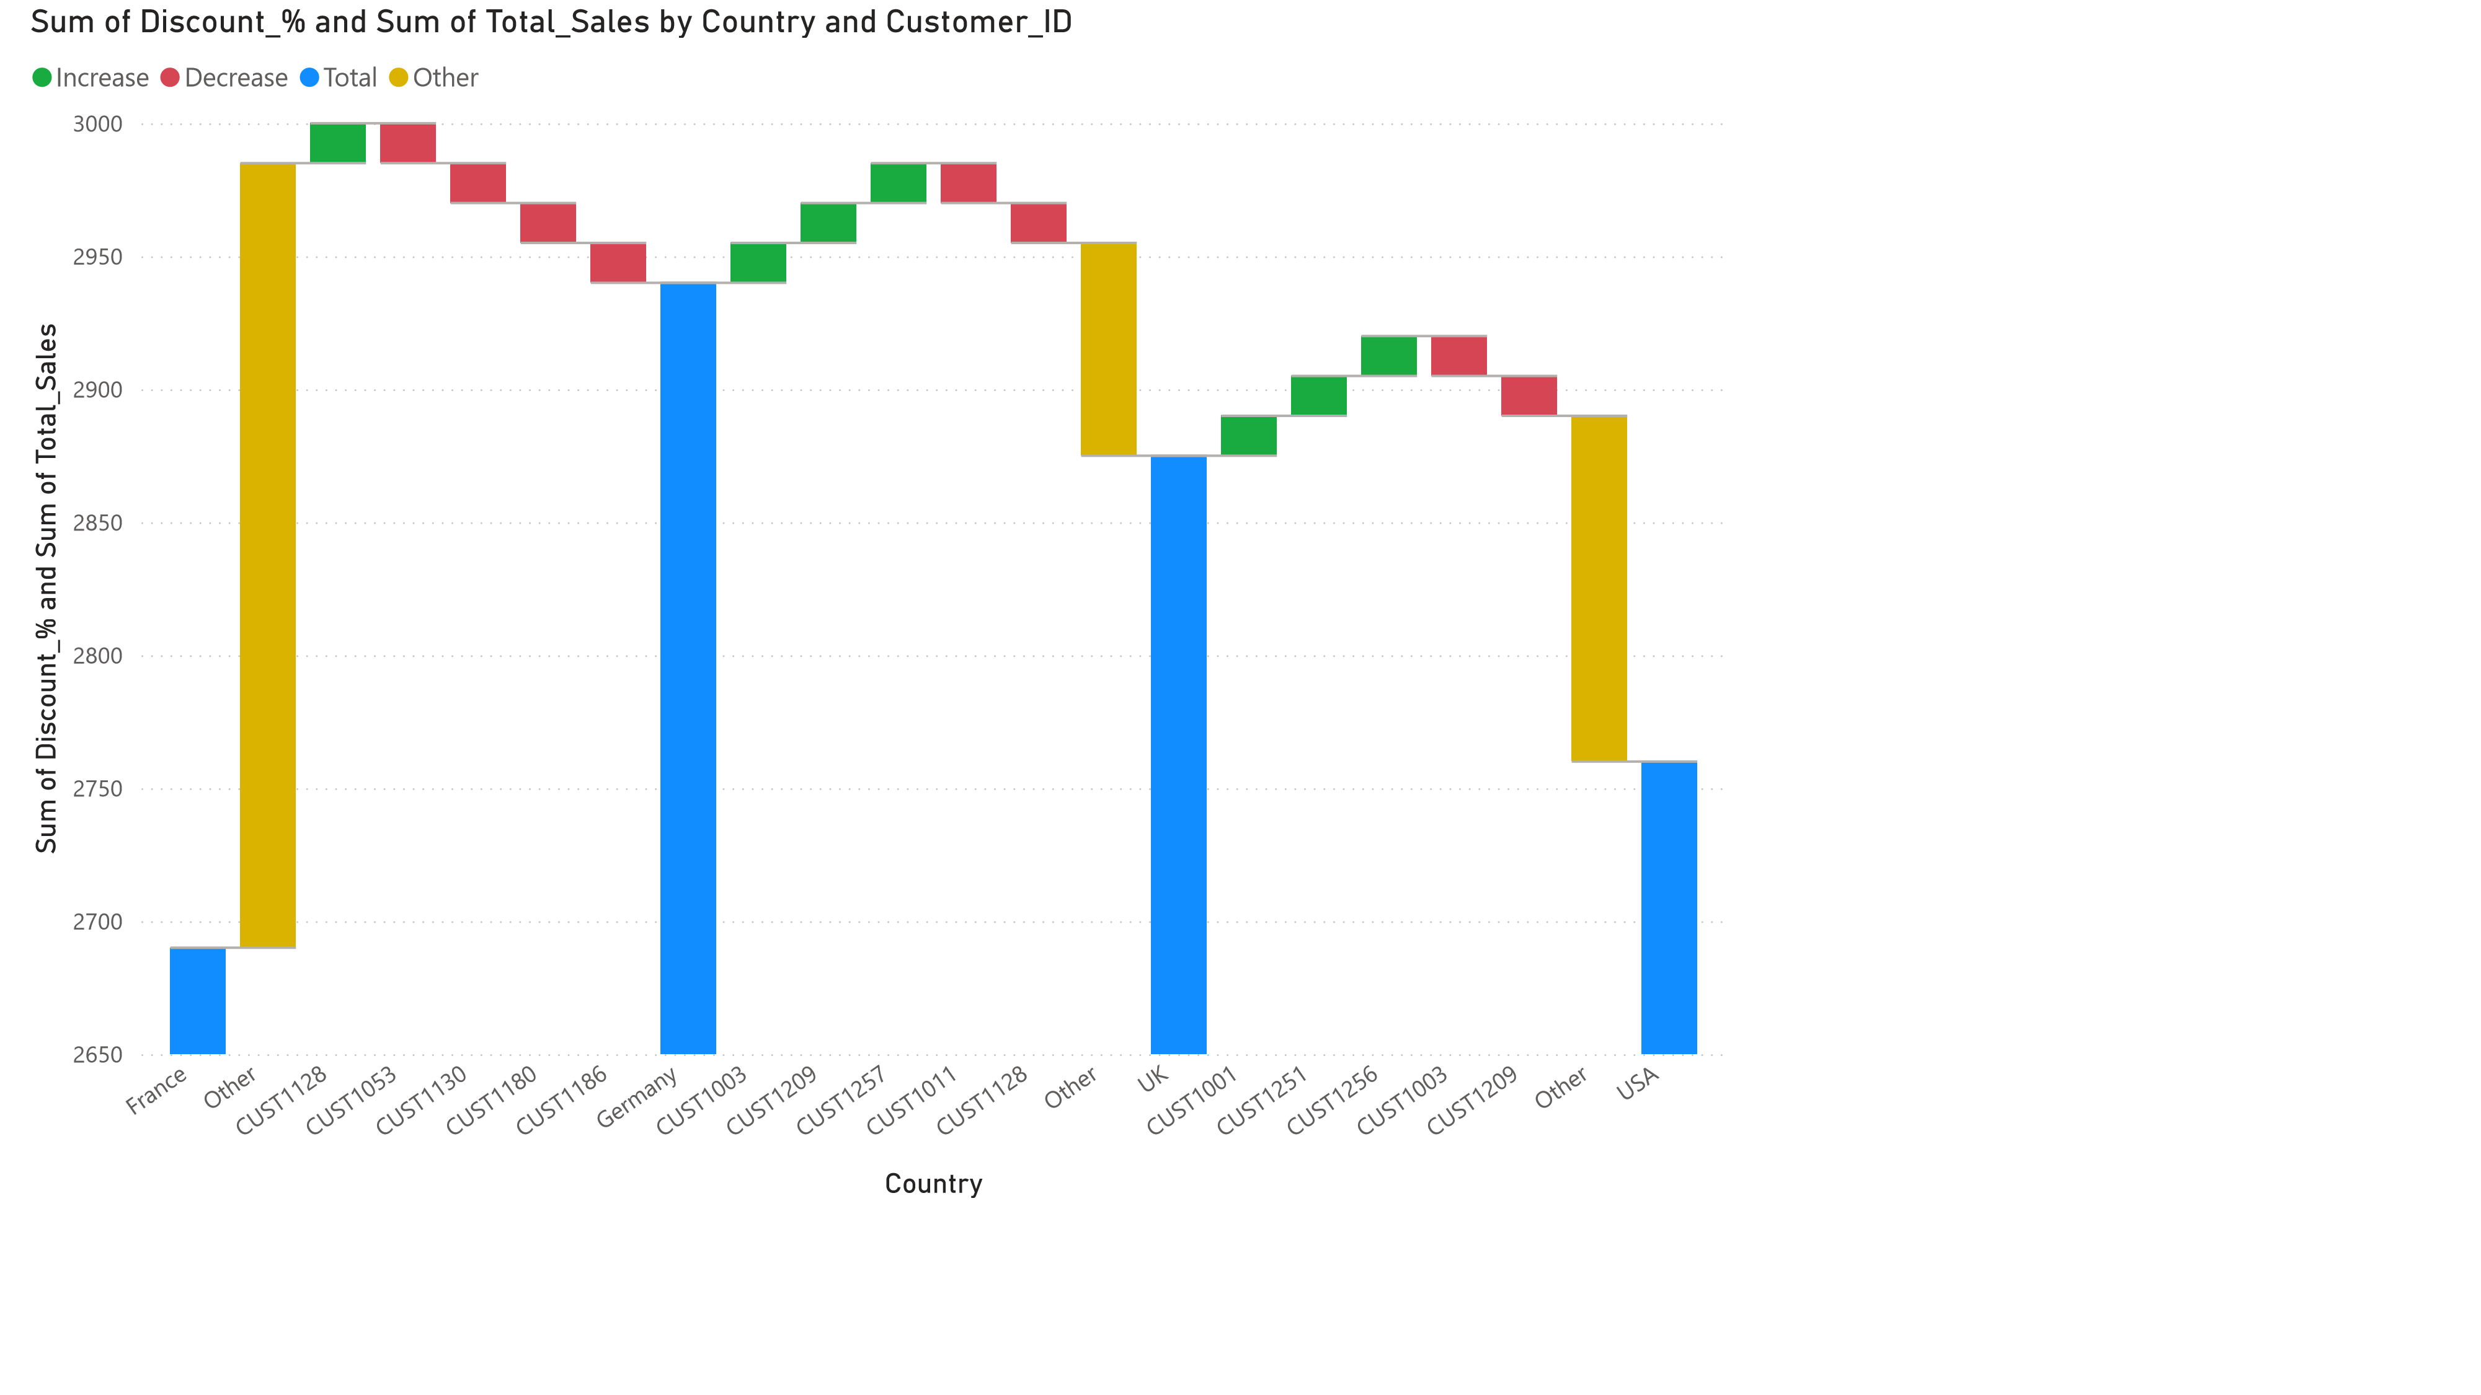
_{Power BI Desktop}
Sum of Discount_% and Sum of Unit_Price by Country
100
%
102.6
%
France
Germany
UK
USA
3
K
3
K
3
K
3
K
Power BI Desktop
Sum of Quantity, Sum of Discount_%, Sum of Total_Sales and Sum of Unit_Price by Quarter
)
K (0.03%
1
587.51K (16.68%)
(6.13%)
(0.03%)
676.03K (19.19%)
)
236
K (6.7%
658.65K (18.7%)
(6.54%)
(0.04%)
669.04K (18.99%)
)
233
K (6.62%
K
216
K
1
K
230
K
1
Order_Date Quarter
Qtr 1
Qtr 2
Qtr 3
Qtr 4
Sum of Discount_%, Sum of Quantity, Sum of Total_Sales and Sum of
Unit_Price by Country
)
3
K (23.88%
3
K (26.1%
)
3
)
K (25.52%
3
)
K (24.5%
Country
France
Germany
UK
USA
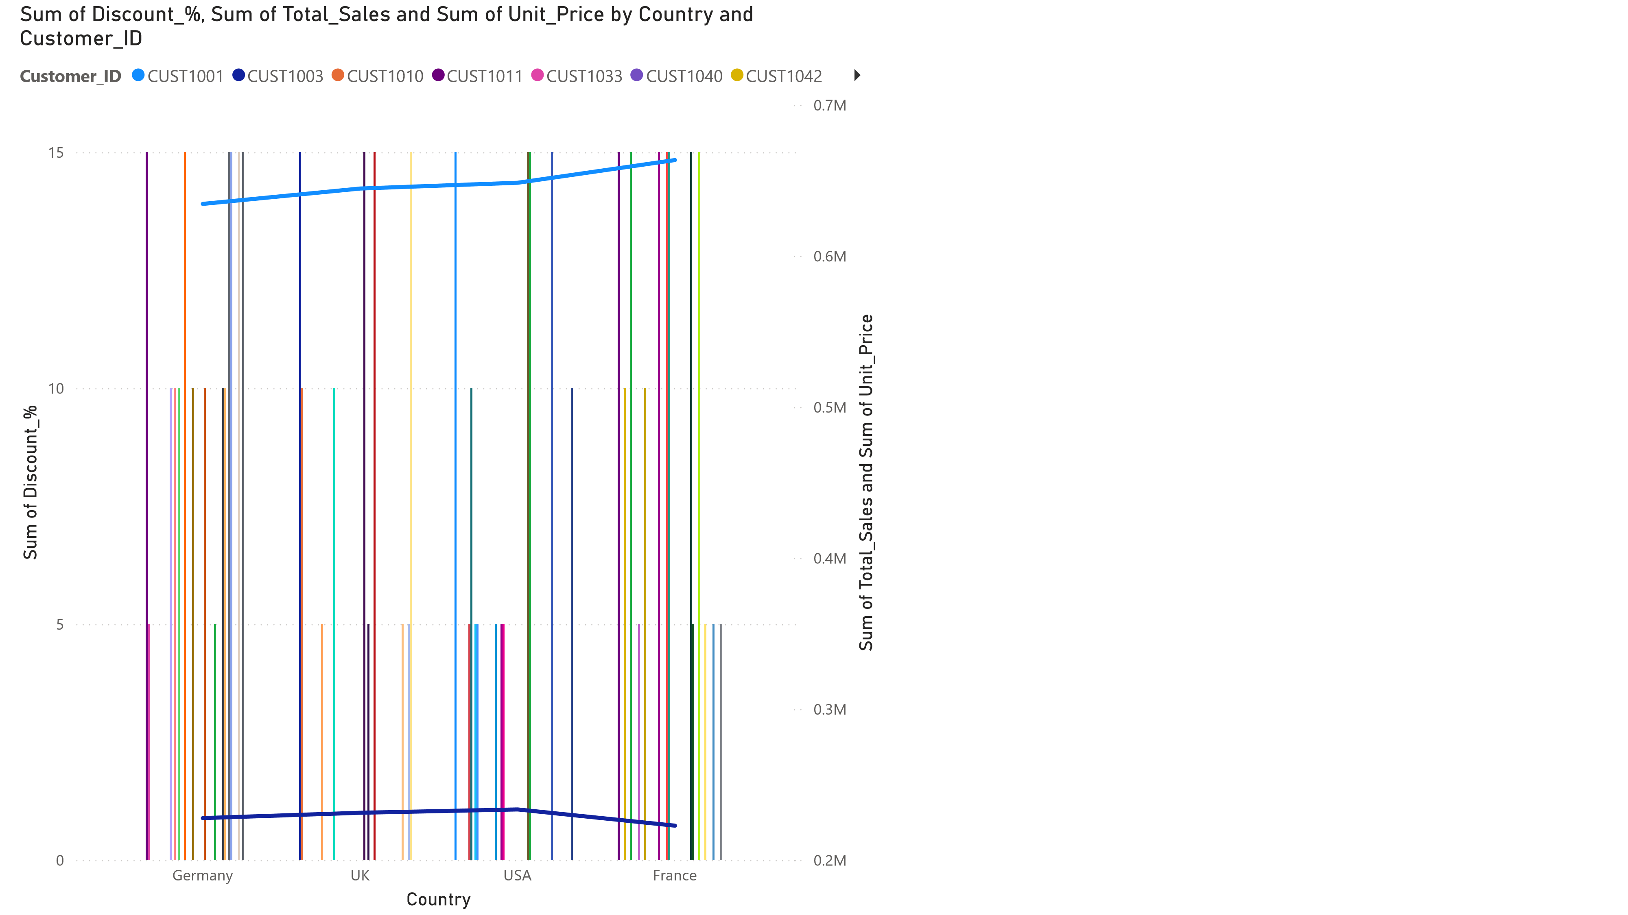
Power BI Desktop
Sum of Discount_%
10
Sum of Quantity
1
Sum of Total_Sales
63.90
Sum of Unit_Price
71
ORD00001
Sum of Discount_%
15
Sum of Quantity
5
Sum of Total_Sales
841.50
Sum of Unit_Price
198
ORD00002
Sum of Discount_%
5
Sum of Quantity
5
Sum of Total_Sales
351.50
Sum of Unit_Price
74
ORD00003


Country, Customer_ID, Discount_%, Order_Date, Order_ID, Product, Quantity, Sal…
   | Power BI Desktop
 | France
 | Germany
 | UK
 | USA
USA  Count  October Month  1 | ry  Sum of Quantity | 10  Sum of Discou…  16  Day  Website  Sales_Channel | 2025 Year  ORD00001 Order_ID  63.90  Sum of Total_Sales | Qtr 4  Quarter  Headphones  Product
USA  Country  October Month  3  Sum of Quantity  USA |  | 10  Sum of Discou…  24  Day  Website  Sales_Channel  10 | 2025 Year  ORD00009 Order_ID  1,212.30  Sum of Total_Sales  2025 | Qtr 4  Quarter  Keyboard  Product  Qtr 4
Power BI Desktop
663.54
K
Sum of Total_Sales
K
223
Sum of Unit_Price
Year
Quarter
Month
Day
Sum of T
2025
Qtr 4
October
19
2025
Qtr 4
October
26
2025
Qtr 4
October
30
2025
Qtr 4
October
31
Total

6
6
,
Earliest Order_Date, First
Sales_Channel, Sum of Total_Sales
and Sum of Unit_Price by Country
France
19
Octob
…
Germ
…
18
Octob
…
UK
17
Octob
…
USA
16
Octob
…

